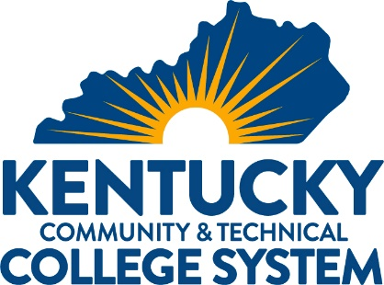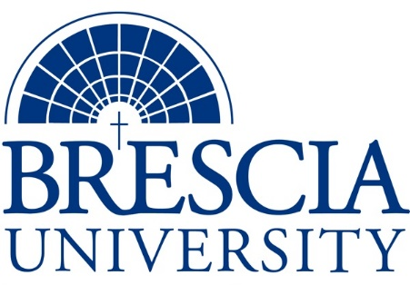

TRANSFER PATHWAY GUIDE

Associate of Applied Science to Bachelor in Integrated Studies
Welding Technology

Overview
Completion of the following curriculum will satisfy the requirements for Associates of Applied Science at the Kentucky Community and Technical College System and leads to a Bachelor’s Degree at Brescia University.

Admission Requirements
Official transcript from all schools attended. Combined grade point of average of a 2.0 or higher.

Degree Requirements
Students can apply to Brescia University at: https://www.brescia.edu/apply/ For any questions or additional information on tuition, deadlines, or start dates, please email BUconnections@brescia.edu

General Transfer Requirements
Brescia University can accept up to 77 hours of transfer credit from KCTCS from their associate of applied science for courses where a student made a grade of C or above.

KCTCS AAS TO BU’s Bachelor Degree CHECKLIST

Kentucky Community and Technical College System

Category 1: KCTCS General Education Core Requirements (15 hours)
KCTCS Course | Course or Category | Credits | {Institution}  Course | Completed
ENG 101 | Writing I | 3
MAT 110 OR MAT 116 OR MAT 146 OR MAT 150 OR MA 109 | Applied Mathematics OR Technical Mathematics OR Contemporary College Mathematics OR College Algebra OR College Algebra | 3
 | Heritage/Humanities* | 3
PHY 151 AND PHY 161 | Introductory Physics I AND Introductory Physics Lab I OR Natural Sciences | 3-4
PSY 110 OR SOC 101 | General Psychology OR Introduction to Sociology | 3
COM 181 | Basic Public Speaking | 3
 | Subtotal General Education Core Courses | 18-19
*World History is required at Brescia University. If not taken at KCTCS, will need to be taken at Brescia.

Category 2: KCTCS Technical and Support Component (42-49 hours)
KCTCS Course | Course or Category | Credits | {Institution}  Course | Completed
 | Computer/Digital Literacy | 0-3
WLD 100 OR WLD 110 | Oxy-Fuel Systems OR Cutting Processes | 2
WLD 101 OR WLD 111 | Oxy-Fuel Systems Lab OR Cutting Processes Lab | 2-3
WLD 120 | Shielded Metal Arc Welding (SMAW) | 2
WLD 121 | Shielded Metal Arc Welding (SMAW) Fillet Lab | 3
WLD 123 OR WLD 225 | Shielded Metal Arc Welding (SMAW) Groove with Backing Lab OR Shielded Metal Arc Welding (SMAW) Open Groove Lab | 3
WLD 130 | Gas Tungsten Arc Welding (GTAW) | 2
WLD 131 | Gas Tungsten Arc Welding (GTAW) Fillet Lab | 3
WLD 133 | Gas Tungsten Arc Welding (GTAW) Groove Lab | 3
WLD 140 | Gas Metal Arc Welding (GMAW) | 2
WLD 141 | Gas Metal Arc Welding (GMAW) Fillet Lab | 3
WLD 143 | Gas Metal Arc Welding (GMAW) Groove Lab | 3
WLD 170 | Blueprint Reading for Welding | 2
WLD 171 | Blueprint Reading for Welding Lab | 3
WLD 220 | Welding Certification | 2
WLD 221 | Welding Certification Lab | 3
WLD 298 OR WLD 299 | Welding Practicum OR Cooperative Work Experience | 1 - 4
 | Technical Electives | 3
 | Subtotal AAS Technical Courses | 42-49

BRESCIA UNIVERSITY

Major Requirements for Integrated Studies, Emphasis in Business
Brescia University Course | Course Name | Credits | {Institution} Course | Taken at KCTCS
Eng 102 | Writing II | 3
Eng 201 | Intro to Fiction | 3
CS 105 | Office Applications | 3
Spn 101 | GER Foreign Language | 3
Drm 325 | Oral Interpretation (GER UD Fine Arts) | 3
Eng 341 or 342 | GER UD Literature | 3
Phl 346 | Business Ethics (GER UD Philosophy) | 3
Psy 105 | Intro to Psychology (or other GER Social Beh Sci) | 3
Th 318 | Faith & Justice (GER UD Theology) | 3
BAd 301 | Business Law | 3
BAd 405 | Management Information Systems | 3
BAd 410 | Public Regulation of Business | 3
Mgt 306 | Management Concepts | 3
Mkt 307 | Marketing Concepts | 3
BAd 418 | Quantitative Methods for Business | 3
Mgt 315 | Personnel/Human Resource Management | 3
IS 499 | Sr. Capstone (Final Paper Required) | 3
SW 310 | Social Issues and Diversity (UD Elective) | 3
Mgt 308 | Organizational Behavior (Or another UD Elective) | 3
Eco 201 | Principles of Economics I (or another Free Elective) | 3
Eco 202 | Principles of Economics II (or another Free Elective) | 3
 | Subtotal BRESCIA Credit Hours | 60-68
 | Total Baccalaureate Degree Credit Hours | 128
Updated: {8-26-2020}

