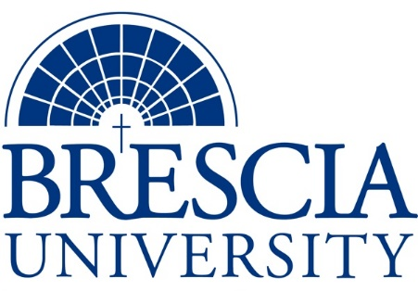

TRANSFER PATHWAY GUIDE

Associate of Applied Science to Bachelor in Integrated Studies
Visual Communication: Communication Arts Technology, Digital Filmmaking Track

Overview
Completion of the following curriculum will satisfy the requirements for Associates of Applied Science at the Kentucky Community and Technical College System and leads to a Bachelor’s Degree at Brescia University.

Admission Requirements
Official transcript from all schools attended. Combined grade point of average of a 2.0 or higher.

Degree Requirements
Students can apply to Brescia University at: https://www.brescia.edu/apply/ For any questions or additional information on tuition, deadlines, or start dates, please email BUconnections@brescia.edu

General Transfer Requirements
Brescia University can accept up to 77 hours of transfer credit from KCTCS from their associate of applied science for courses where a student made a grade of C or above.

KCTCS AAS TO BU’s Bachelor Degree CHECKLIST

Kentucky Community and Technical College System

Category 1: KCTCS General Education Core Requirements (15 hours)
KCTCS Course | Course or Category | Credits | {Institution}  Course | Completed
ENG 101 | Writing I | 3
ART 106 | Renaissance Through Modern Art History | 3
MAT 110 OR MAT 146 OR MAT 150 | Applied Mathematics OR Contemporary College Mathematics OR College Algebra | 3
 | Social/Behavioral Sciences | 3
 | Natural Sciences | 3
 | Subtotal General Education Core Courses | 15

Category 2: KCTCS Technical and Support Component (50-53 hours)
KCTCS Course | Course or Category | Credits | {Institution}  Course | Completed
VCC 150 | Mac Basics OR any Computer/Digital Literacy equivalent* | 0-3
VCC 100 | Introduction to Visual Communication | 3
ART 110 | Drawing I | 3
VCA 132 | Illustration for Advertising | 3
VCA 170 | Advertising Design I | 3
VCA 171 | Advertising Design II | 3
VCA 160 | Commercial Photography I | 3
VCA 161 | Commercial Photography II | 3
VCC 166 | Photoshop Basics | 3
ENG 207 | Beginning Workshop in Imaginative Writing: Scriptwriting | 3
MUS 120 | Music Technology I | 3
THA 126 | Acting I: Fundamentals of Acting | 3
VCA 151 | Digital Filmmaking I | 3
VCA 152 | Digital Filmmaking II | 3
VCA 251 | Digital Filmmaking III | 3
VCA 252 | Digital Filmmaking IV | 3
VCA 290 | Folio Seminar | 3
VCA 298 | Practicum | 2
 | Subtotal AAS Technical Courses | 50-53

BRESCIA UNIVERSITY

Major Requirements for Integrated Studies, Emphasis in Business
Brescia University Course | Course Name | Credits | {Institution} Course | Taken at KCTCS
Eng 102 | Writing II | 3
Eng 201 | Intro to Fiction | 3
Sph 110 | Public Speaking | 3
CS 105 | Office Applications | 3
Spn 101 | GER Foreign Language | 3
Drm 325 | Oral Interpretation (GER UD Fine Arts) | 3
Eng 341 or 342 | GER UD Literature | 3
Phl 346 | Business Ethics (GER UD Philosophy) | 3
Psy 105 | Intro to Psychology (GER Social Beh Sci) | 3
Th 318 | Faith & Justice (GER UD Theology) | 3
BAd 301 | Business Law | 3
BAd 405 | Management Information Systems | 3
BAd 410 | Public Regulation of Business | 3
Mgt 306 | Management Concepts | 3
Mkt 307 | Marketing Concepts | 3
Mgt 315 | Personnel/Human Resource Management | 3
BAd 418 | Quantitative Methods for Business | 3
IS 499 | Sr. Capstone (Final Paper Required) | 3
SW 310 | Social Issues and Diversity (UD Elective) | 3
Mgt 308 | Organizational Behavior (Or another UD Elective) | 3
His 102 | World Civ II | 3
 | Subtotal BRESCIA Credit Hours | 60-63
 | Total Baccalaureate Degree Credit Hours | 128
Updated: {8-26-2020}

