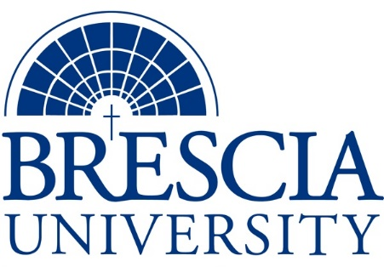

TRANSFER PATHWAY GUIDE

Associate of Applied Science to Bachelor in Integrated Studies
Professional Studio Artist, Bluegrass and Traditional Music Track

Overview
Completion of the following curriculum will satisfy the requirements for Associates of Applied Science at the Kentucky Community and Technical College System and leads to a Bachelor’s Degree at Brescia University.

Admission Requirements
Official transcript from all schools attended. Combined grade point of average of a 2.0 or higher.

Degree Requirements
Students can apply to Brescia University at: https://www.brescia.edu/apply/ For any questions or additional information on tuition, deadlines, or start dates, please email BUconnections@brescia.edu

General Transfer Requirements
Brescia University can accept up to 77 hours of transfer credit from KCTCS from their associate of applied science for courses where a student made a grade of C or above.

KCTCS AAS TO BU’s Bachelor Degree CHECKLIST

Kentucky Community and Technical College System

Category 1: KCTCS General Education Core Requirements (18-19 hours)
KCTCS Course | Course or Category | Credits | {Institution}  Course | Completed
ENG 101 | Writing I | 3
MAT 110 | Applied Mathematics OR higher level Quantitative Reasoning course | 3
COM 181 | Basic Public Speaking | 3
 | Heritage/ Humanities* | 3
 | Natural Sciences | 3-4
 | Social/Behavioral Sciences | 3
 | Subtotal General Education Core Courses | 18-19
*World History is required at Brescia University. If not taken at KCTCS, will need to be taken at Brescia.

Category 2: KCTCS Technical and Support Component (42-44 hours)
KCTCS Course | Course or Category | Credits | {Institution}  Course | Completed
BAS 200 | Small Business Management | 3
ACT 101 | Fundamentals of Accounting I | 3
MUS 174 | Theory for Non-Music Majors | 3
MUC 150 | Classic Instruction to Piano OR Competency by audition | 0-1
PSM 101 | Bluegrass & Traditional Music History I | 3
PSM 105 | Recording I | 1
PSM 107 | Songwriting I | 1
PSM 112 | Individual String Instrument Instruction x 4 | 4
PSM 113 | Guitar I OR Competency by audition | 0-1
PSM 114 | Bluegrass & Traditional Band/Ensemble x4 | 8
PSM 118 | Bluegrass & Traditional Harmony/Part Singing | 2
PSM 121 | Bluegrass & Traditional Music History II | 3
PSM 125 OR PSM 117 | Recording II OR Songwriting II | 1
PSM 231 | Bluegrass & Traditional Music III | 3
PSM 235 OR PSM 217 | Recording III OR Songwriting III | 2
PSM 245 OR PSM 227 | Recording IV OR Songwriting IV | 2
PSA 240 | Professional Artist Seminar | 3
 | Subtotal AAS Technical Courses | 42-44

BRESCIA UNIVERSITY

Major Requirements for Integrated Studies, Emphasis in Business
Brescia University Course | Course Name | Credits | {Institution} Course | Taken at KCTCS
Eng 102 | Writing II | 3
Eng 201 | Intro to Fiction | 3
CS 105 | Office Applications | 3
Spn 101 | GER Foreign Language | 3
Drm 325 | Oral Interpretation (GER UD Fine Arts) | 3
Eng 341 or 342 | GER UD Literature | 3
Phl 346 | Business Ethics (GER UD Philosophy) | 3
Psy 105 | Intro to Psychology (GER Social Beh Sci) | 3
Th 318 | Faith & Justice (GER UD Theology) | 3
BAd 301 | Business Law | 3
BAd 405 | Management Information Systems | 3
BAd 410 | Public Regulation of Business | 3
Mgt 306 | Management Concepts | 3
Mkt 307 | Marketing Concepts | 3
BAd 418 | Quantitative Methods for Business | 3
Mgt 315 | Personnel/Human Resource Management | 3
IS 499 | Sr. Capstone (Final Paper Required) | 3
SW 310 | Social Issues and Diversity (UD Elective) | 3
Mgt 308 | Organizational Behavior (Or another UD Elective) | 3
Eco 201 | Principles of Economics I (or another Free Elective) | 3
Eco 202 | Principles of Economics II (or another Free Elective) | 3
 | Free Elective, if needed | 3-6
 | Subtotal BRESCIA Credit Hours | 65-68
 | Total Baccalaureate Degree Credit Hours | 128
Updated: {8-26-2020}

