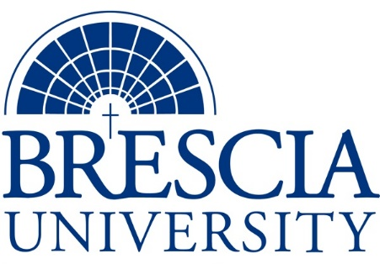

TRANSFER PATHWAY GUIDE

Associate of Applied Science to Bachelor in Integrated Studies
Physical Therapist Assistant, Pathway 1

Overview
Completion of the following curriculum will satisfy the requirements for Associates of Applied Science at the Kentucky Community and Technical College System and leads to a Bachelor’s Degree at Brescia University.

Admission Requirements
Official transcript from all schools attended. Combined grade point of average of a 2.0 or higher.

Degree Requirements
Students can apply to Brescia University at: https://www.brescia.edu/apply/ For any questions or additional information on tuition, deadlines, or start dates, please email BUconnections@brescia.edu

General Transfer Requirements
Brescia University can accept up to 77 hours of transfer credit from KCTCS from their associate of applied science for courses where a student made a grade of C or above.

KCTCS AAS TO BU’s Bachelor Degree CHECKLIST

Kentucky Community and Technical College System

Category 1: KCTCS General Education Core Requirements (26 hours)
KCTCS Course | Course or Category | Credits | {Institution}  Course | Completed
ENG 101 | Writing I | 3
BIO 137 | Human Anatomy and Physiology I | 4
BIO 139 | Human Anatomy and Physiology II | 4
 | Heritage/Humanities* | 3
PSY 110 | General Psychology | 3
PSY 223 | Developmental Psychology | 3
MAT 150 | College Algebra or higher | 3
COM 181 | Basic Public Speaking | 3
 | Subtotal General Education Core Courses | 26
*World History is required at Brescia University. If not taken at KCTCS, will need to be taken at Brescia.

Category 2: KCTCS Technical and Support Component (40-43 hours)
KCTCS Course | Course or Category | Credits | {Institution}  Course | Completed
 | Digital Literacy | 0-3
PTA 101 | Orientation to Physical Therapy Practice | 5
PTA 125 | Neuroanatomy for the PTA | 1
PTA 150 | Functional Anatomy and Kinesiology | 6
PTA 160 | Medical and Surgical Conditions in Physical Therapy | 3
PTA 170 | Clinical Practicum I | 1
PTA 200 | Modalities and Procedures in Physical Therapy | 5
PTA 220 | Physical Therapy Principles and Procedures | 5
PTA 240 | Clinical Practicum II | 2
PTA 250 | Neurological Rehabilitation in Physical Therapy | 5
PTA 260 | Seminar in Physical Therapy | 2
PTA 280 | Clinical Practicum III | 5
 | Subtotal AAS Technical Courses | 40-43

BRESCIA UNIVERSITY

Major Requirements for Integrated Studies, Emphasis in Business
Brescia University Course | Course Name | Credits | {Institution} Course | Taken at KCTCS
Eng 102 | Writing II | 3
Eng 201 | Intro to Fiction | 3
CS 105 | Office Applications | 3
Spn 101 | GER Foreign Language | 3
Drm 325 | Oral Interpretation (GER UD Fine Arts) | 3
Eng 341 or 342 | GER UD Literature | 3
Phl 346 | Business Ethics (GER UD Philosophy) | 3
Th 318 | Faith & Justice (GER UD Theology) | 3
BAd 301 | Business Law | 3
BAd 405 | Management Information Systems | 3
BAd 410 | Public Regulation of Business | 3
Mgt 306 | Management Concepts | 3
Mkt 307 | Marketing Concepts | 3
BAd 418 | Quantitative Methods for Business | 3
Mgt 315 | Personnel/Human Resource Management | 3
IS 499 | Sr. Capstone (Final Paper Required) | 3
SW 310 | Social Issues and Diversity (UD Elective) | 3
Mgt 308 | Organizational Behavior (Or another UD Elective) | 3
Eco 201 | Principles of Economics I (or another Free Elective) | 3
Eco 202 | Principles of Economics II (or another Free Elective) | 3
 | Subtotal BRESCIA Credit Hours | 59-62
 | Total Baccalaureate Degree Credit Hours | 128
Updated: {8-26-2020}

