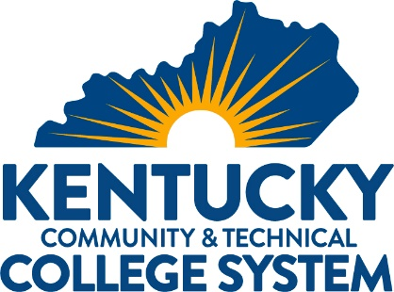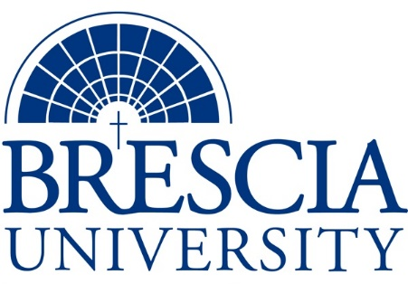

TRANSFER PATHWAY GUIDE

Associate of Applied Science to Bachelor in Integrated Studies
Mining Technology, Mechanics Track

Overview
Completion of the following curriculum will satisfy the requirements for Associates of Applied Science at the Kentucky Community and Technical College System and leads to a Bachelor’s Degree at Brescia University.

Admission Requirements
Official transcript from all schools attended. Combined grade point of average of a 2.0 or higher.

Degree Requirements
Students can apply to Brescia University at: https://www.brescia.edu/apply/ For any questions or additional information on tuition, deadlines, or start dates, please email BUconnections@brescia.edu

General Transfer Requirements
Brescia University can accept up to 77 hours of transfer credit from KCTCS from their associate of applied science for courses where a student made a grade of C or above.

KCTCS AAS TO BU’s Bachelor Degree CHECKLIST

Kentucky Community and Technical College System

Category 1: KCTCS General Education Core Requirements (16 hours)
KCTCS Course | Course or Category | Credits | {Institution}  Course | Completed
ENG 101 | Writing I | 3
 | Quantitative Reasoning course* | 3
 | Social/Behavioral Science course | 3
GLY 101 AND GLY 111 | Physical Geology AND Laboratory for Physical Geology OR Natural Sciences | 4
 | Heritage/Humanities* | 3
 | Subtotal General Education Core Courses | 16
*World History is required at Brescia University. If not taken at KCTCS, will need to be taken at Brescia.

Category 2: KCTCS Technical and Support Component (46-49 hours)
KCTCS Course | Course or Category | Credits | {Institution}  Course | Completed
 | Digital Literacy | 3
MNG 102 | Introduction to Mine Engineering and Mining Technology | 3
MNG 160 | Elements of Underground Mining | 3
MNG 170 | Elements of Surface Mining | 2
MNG 150 | Mining Laws | 3
BAS 160 | Introduction to Business | 3
EFM 100 OR BAS 120 | Personal Financial Management OR Personal Finance | 3
MNG 274 | Mine Safety | 3
MNG 180 | Environmental Issues in Mining | 3
 | Blueprint Reading course | 2-3
ELT 265 OR FPX 100 AND FPX 101 | Applied Fluid Power OR Fluid Power AND Fluid Power Lab | 3-5
ELT 122 | Mechanical Power Transmission Systems | 3
IMT 100 | Welding for Maintenance | 3
IMT 101 | Welding for Maintenance Lab | 2
IMT 150 | Maintaining Industrial Equipment I | 3
IMT 151 | Maintaining Industrial Equipment I Lab | 2
 | Technical Electives* | 2
 | Subtotal AAS Technical Courses | 46-49

BRESCIA UNIVERSITY

Major Requirements for Integrated Studies, Emphasis in Business
Brescia University Course | Course Name | Credits | {Institution} Course | Taken at KCTCS
Eng 102 | Writing II | 3
Eng 201 | Intro to Fiction | 3
Sph 110 | Public Speaking | 3
CS 105 | Office Applications | 3
Spn 101 | GER Foreign Language | 3
Drm 325 | Oral Interpretation (GER UD Fine Arts) | 3
Eng 341 or 342 | GER UD Literature | 3
Phl 346 | Business Ethics (GER UD Philosophy) | 3
Psy 105 | Intro to Psychology (GER Social Beh Sci) | 3
Th 318 | Faith & Justice (GER UD Theology) | 3
BAd 301 | Business Law | 3
BAd 405 | Management Information Systems | 3
BAd 410 | Public Regulation of Business | 3
Mgt 306 | Management Concepts | 3
Mkt 307 | Marketing Concepts | 3
BAd 418 | Quantitative Methods for Business | 3
Mgt 315 | Personnel/Human Resource Management | 3
IS 499 | Sr. Capstone (Final Paper Required) | 3
SW 310 | Social Issues and Diversity (UD Elective) | 3
Mgt 308 | Organizational Behavior (Or another UD Elective) | 3
Eco 201 | Principles of Economics I (or another Free Elective) | 3
Eco 202 | Principles of Economics II (or another Free Elective) | 3
 | Subtotal BRESCIA Credit Hours | 63-66
 | Total Baccalaureate Degree Credit Hours | 128
Updated: {8-26-2020}

