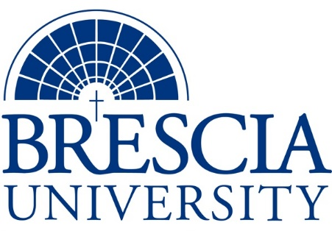

TRANSFER PATHWAY GUIDE

Associate of Applied Science to Bachelor in Integrated Studies
Massage Therapy Technology

Overview
Completion of the following curriculum will satisfy the requirements for Associates of Applied Science at the Kentucky Community and Technical College System and leads to a Bachelor’s Degree at Brescia University.

Admission Requirements
Official transcript from all schools attended. Combined grade point of average of a 2.0 or higher.

Degree Requirements
Students can apply to Brescia University at: https://www.brescia.edu/apply/ For any questions or additional information on tuition, deadlines, or start dates, please email BUconnections@brescia.edu

General Transfer Requirements
Brescia University can accept up to 77 hours of transfer credit from KCTCS from their associate of applied science for courses where a student made a grade of C or above.

KCTCS AAS TO BU’s Bachelor Degree CHECKLIST

Kentucky Community and Technical College System

Category 1: KCTCS General Education Core Requirements (28-32 hours)
KCTCS Course | Course or Category | Credits | {Institution}  Course | Completed
ENG 101 | Writing I | 3
ENG 102 | Writing II | 3
COM 252 | Introduction to Interpersonal Communication | 3
MAT 110 | Applied Mathematics OR Higher-Level Quantitative Reasoning Course | 3
BIO 135 OR BIO 137 AND BIO 139 | Basic Anatomy and Physiology OR Human Anatomy and Physiology I AND Human Anatomy and Physiology II | 4-8
PHI 110 OR PHI 150 | Medical Ethics OR Business Ethics | 3
PSY 110 | General Psychology | 3
 | Social/Behavioral Sciences | 3
 | Heritage/Humanities* | 3
 | Subtotal General Education Core Courses | 28-32
*World History is required at Brescia University. If not taken at KCTCS, will need to be taken at Brescia.

Category 2: KCTCS Technical and Support Component (33-35 hours)
KCTCS Course | Course or Category | Credits | {Institution}  Course | Completed
 | Digital Literacy | 0-3
AHS 115 | Medical Terminology | 3
CPR 100 | CPR for Healthcare Professionals | 1
BAS 200 OR BAS 288 | Small Business Management OR Personal and Organizational Leadership | 3
MSG 117 | Musculoskeletal Anatomy and Physiology I | 4
MSG 119 | Musculoskeletal Anatomy and Physiology II | 4
MSG 132 | Massage Technique I | 3
MSG 134 | Massage Technique II | 3
MSG 220 | Massage Therapy Practice | 3
MSG 232 | Advanced Clinical Massage I | 3
MSG 234 | Advanced Clinical Massage II | 3
MSG 286 | Massage Therapy Student Clinic | 3
 | Subtotal AAS Technical Courses | 33-36

BRESCIA UNIVERSITY

Major Requirements for Integrated Studies, Emphasis in Business
Brescia University Course | Course Name | Credits | {Institution} Course | Taken at KCTCS
Eng 201 | Intro to Fiction | 3
Sph 110 | Public Speaking | 3
CS 105 | Office Applications | 3
Spn 101 | GER Foreign Language | 3
Drm 325 | Oral Interpretation (GER UD Fine Arts) | 3
Eng 341 or 342 | GER UD Literature | 3
Phl 346 | Business Ethics (GER UD Philosophy) | 3
Soc 204 | Principles of Sociology (GER Social Beh Sci) | 3
Th 318 | Faith & Justice (GER UD Theology) | 3
BAd 301 | Business Law | 3
BAd 405 | Management Information Systems | 3
BAd 410 | Public Regulation of Business | 3
Mgt 306 | Management Concepts | 3
Mkt 307 | Marketing Concepts | 3
BAd 418 | Quantitative Methods for Business | 3
Mgt 315 | Personnel/Human Resource Management | 3
IS 499 | Sr. Capstone (Final Paper Required) | 3
SW 310 | Social Issues and Diversity (UD Elective) | 3
Mgt 308 | Organizational Behavior (Or another UD Elective) | 3
Eco 201 | Principles of Economics I (or another Free Elective) | 3
Eco 202 | Principles of Economics II (or another Free Elective) | 3
 | Subtotal BRESCIA Credit Hours | 60-67
 | Total Baccalaureate Degree Credit Hours | 128
Updated: {8-26-2020}

