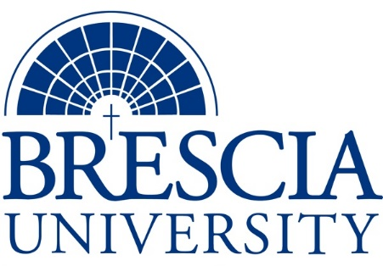

TRANSFER PATHWAY GUIDE

Associate of Applied Science to Bachelor in Integrated Studies
Marine Technology, Marine Culinary Management

Overview
Completion of the following curriculum will satisfy the requirements for Associates of Applied Science at the Kentucky Community and Technical College System and leads to a Bachelor’s Degree at Brescia University.

Admission Requirements
Official transcript from all schools attended. Combined grade point of average of a 2.0 or higher.

Degree Requirements
Students can apply to Brescia University at: https://www.brescia.edu/apply/ For any questions or additional information on tuition, deadlines, or start dates, please email BUconnections@brescia.edu

General Transfer Requirements
Brescia University can accept up to 77 hours of transfer credit from KCTCS from their associate of applied science for courses where a student made a grade of C or above.

KCTCS AAS TO BU’s Bachelor Degree CHECKLIST

Kentucky Community and Technical College System

Category 1: KCTCS General Education Core Requirements (15 hours)
KCTCS Course | Course or Category | Credits | {Institution}  Course | Completed
MAT 116 | Technical Mathematics or Higher Quantitative Reasoning | 3
 | Natural Sciences | 3
GEN 140 | Development of Leadership | 3
 | Heritage/ Humanities* | 3
ENG 101 | Writing I | 3
 | Subtotal General Education Core Courses | 15
*World History is required at Brescia University. If not taken at KCTCS, will need to be taken at Brescia.

Category 2: KCTCS Technical and Support Component (46-49 hours)
KCTCS Course | Course or Category | Credits | {Institution}  Course | Completed
 | Digital Literacy | 0-3
BAS 160 | Introduction to Business | 3
MRN 100 | Introduction to Marine Technology | 3
MRN 101 | Anatomy of a Towboat | 3
MRN 102 | Basic Marine Safety | 3
MRN 103 | Applied Marine Weather | 3
MRN 104 | Marine Crew Wellness | 3
MRN 203 | Environmental Protection Rules | 3
HSM 100 | Introduction to Homeland Security | 3
HSM 110 | Introduction to Emergency Management | 3
BAS 120 | Personal Finance | 3
BAS 283 | Principles of Management | 3
CUL 100 | Introduction to Culinary Arts | 2
CUL 125 | Sanitation and Safety | 2
CUL 230 | Basic Nutrition | 3
CUL 280 | Cost and Control | 3
MRN 208 | Inland River Systems | 3
 | Subtotal AAS Technical Courses | 46-49

BRESCIA UNIVERSITY

Major Requirements for Integrated Studies, Emphasis in Business
Brescia University Course | Course Name | Credits | {Institution} Course | Taken at KCTCS
Eng 102 | Writing II | 3
Eng 201 | Intro to Fiction | 3
Sph 110 | Public Speaking | 3
CS 105 | Office Applications | 3
Spn 101 | GER Foreign Language | 3
Drm 325 | Oral Interpretation (GER UD Fine Arts) | 3
Eng 341 or 342 | GER UD Literature | 3
Phl 346 | Business Ethics (GER UD Philosophy) | 3
Psy 105 | Intro to Psychology (GER Social Beh Sci) | 3
Th 318 | Faith & Justice (GER UD Theology) | 3
BAd 301 | Business Law | 3
BAd 405 | Management Information Systems | 3
BAd 410 | Public Regulation of Business | 3
Eco 307 | Money and Banking | 3
Mkt 307 | Marketing Concepts | 3
BAd 418 | Quantitative Methods for Business | 3
Mgt 315 | Personnel/Human Resource Management | 3
IS 499 | Sr. Capstone (Final Paper Required) | 3
SW 310 | Social Issues and Diversity (UD Elective) | 3
Mgt 308 | Organizational Behavior (Or another UD Elective) | 3
Eco 201 | Principles of Economics I (or another Free Elective) | 3
Eco 202 | Principles of Economics II (or another Free Elective) | 3
 | Subtotal BRESCIA Credit Hours | 64-67
 | Total Baccalaureate Degree Credit Hours | 128
Updated: {8-26-2020}

