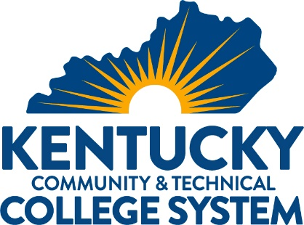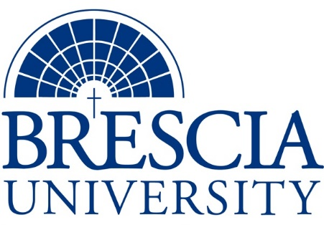

TRANSFER PATHWAY GUIDE

Associate of Applied Science to Bachelor in Integrated Studies
MIT: Electrical Technology, Industrial Automation and Process Control Technician

Overview
Completion of the following curriculum will satisfy the requirements for Associates of Applied Science at the Kentucky Community and Technical College System and leads to a Bachelor’s Degree at Brescia University.

Admission Requirements
Official transcript from all schools attended. Combined grade point of average of a 2.0 or higher.

Degree Requirements
Students can apply to Brescia University at: https://www.brescia.edu/apply/ For any questions or additional information on tuition, deadlines, or start dates, please email BUconnections@brescia.edu

General Transfer Requirements
Brescia University can accept up to 77 hours of transfer credit from KCTCS from their associate of applied science for courses where a student made a grade of C or above.

KCTCS AAS TO BU’s Bachelor Degree CHECKLIST

Kentucky Community and Technical College System

Category 1: KCTCS General Education Core Requirements (18 hours)
KCTCS Course | Course or Category | Credits | {Institution}  Course | Completed
ENG 101 | Writing I | 3
MAT 116 OR MAT 126 | Technical Mathematics OR Technical Algebra & Trigonometry OR Higher Level Quantitative Reasoning Course | 3
 | Natural Sciences | 3
 | Social/Behavioral Sciences | 3
 | Heritage/Humanities* | 3
COM 181 | Basic Public Speaking | 3
 | Subtotal General Education Core Courses | 18
*World History is required at Brescia University. If not taken at KCTCS, will need to be taken at Brescia.

Category 2: KCTCS Technical and Support Component (47-50 hours)
KCTCS Course | Course or Category | Credits | {Institution}  Course | Completed
ELT 110 OR EET 119 | Circuits I OR Basic Electricity | 5
 | Approved Course(s) from Specific Track Technical Electives | 4-5
EET 250 | National Electric Code | 4
EET 264 AND EET 265 AND EET 270 AND EET 271 OR EET 268 AND EET 269 OR EET 266 AND EET 267 | Rotating Machinery AND Rotating Machinery Lab AND Electrical Motor Controls I AND Electrical Motor Controls I Lab OR Rotating Machinery and Electrical Motor Controls I AND Rotating Machinery and Electrical Motor Controls I Lab OR Rotating Machinery and Transformers AND Rotating Machinery and Transformers Lab | 6-8
EET 127 | Electrical Capstone | 1
 | Digital Literacy | 3
ISM 102 | Fundamentals of Instrumentation | 4
ISM 210 | Fundamentals of Process Control | 4
FPX 100 | Fluid Power | 3
FPX 101 | Fluid Power Lab | 2
EET 272 | Electrical Motor Controls II | 2
EET 273 | Electrical Motor Controls II Lab | 2
EET 276 | Programmable Logic Controllers | 2
EET 277 | Programmable Logic Controllers Lab | 2
 | Technical Electives | 3
 | Subtotal AAS Technical Courses | 47-50

BRESCIA UNIVERSITY

Major Requirements for Integrated Studies, Emphasis in Business
Brescia University Course | Course Name | Credits | {Institution} Course | Taken at KCTCS
Eng 102 | Writing II | 3
Eng 201 | Intro to Fiction | 3
CS 105 | Office Applications | 3
Spn 101 | GER Foreign Language | 3
Drm 325 | Oral Interpretation (GER UD Fine Arts) | 3
Eng 341 or 342 | GER UD Literature | 3
Phl 346 | Business Ethics (GER UD Philosophy) | 3
Psy 105 | Intro to Psychology (GER Social Beh Sci) | 3
Th 318 | Faith & Justice (GER UD Theology) | 3
BAd 301 | Business Law | 3
BAd 405 | Management Information Systems | 3
BAd 410 | Public Regulation of Business | 3
Mgt 306 | Management Concepts | 3
Mkt 307 | Marketing Concepts | 3
BAd 418 | Quantitative Methods for Business | 3
Mgt 315 | Personnel/Human Resource Management | 3
IS 499 | Sr. Capstone (Final Paper Required) | 3
SW 310 | Social Issues and Diversity (UD Elective) | 3
Mgt 308 | Organizational Behavior (Or another UD Elective) | 3
Eco 201 | Principles of Economics I (or another Free Elective) | 3
Eco 202 | Principles of Economics II (or another Free Elective) | 3
 | Subtotal BRESCIA Credit Hours | 60-63
 | Total Baccalaureate Degree Credit Hours | 128
Updated: {8-26-2020}

