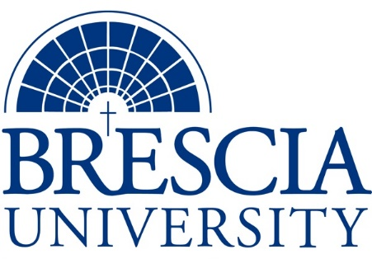

TRANSFER PATHWAY GUIDE

Associate of Applied Science to Bachelor in Integrated Studies
General Occupational/Technical Studies

Overview
Completion of the following curriculum will satisfy the requirements for Associates of Applied Science at the Kentucky Community and Technical College System and leads to a Bachelor’s Degree at Brescia University.

Admission Requirements
Official transcript from all schools attended. Combined grade point of average of a 2.0 or higher.

Degree Requirements
Students can apply to Brescia University at: https://www.brescia.edu/apply/ For any questions or additional information on tuition, deadlines, or start dates, please email BUconnections@brescia.edu

General Transfer Requirements
Brescia University can accept up to 77 hours of transfer credit from KCTCS from their associate of applied science for courses where a student made a grade of C or above.

KCTCS AAS TO BU’s Bachelor Degree CHECKLIST

Kentucky Community and Technical College System

Category 1: KCTCS General Education Core Requirements (15-20 hours)
KCTCS Course | Course or Category | Credits | {Institution}  Course | Completed
 | Quantitative Reasoning | 3
 | Natural Sciences | 3
 | Social/ Behavioral Sciences | 3
 | Heritage/ Humanities* | 3
ENG 101 | Writing I | 3
 | Additional General Education Coursework | 0-5
 | Subtotal General Education Core Courses | 15-20
*World History is required at Brescia University. If not taken at KCTCS, will need to be taken at Brescia.

Category 2: KCTCS Technical and Support Component (45-53 hours)
KCTCS Course | Course or Category | Credits | {Institution}  Course | Completed
 | Computer/Digital Literacy | 0-3
 | Technical Courses² | 45-50
 | Subtotal AAS Technical Courses | 45-53
²The student must have a plan of study on file in the academic affairs office.

BRESCIA UNIVERSITY

Major Requirements for Integrated Studies, Emphasis in Business
Brescia University Course | Course Name | Credits | {Institution} Course | Taken at KCTCS
Eng 102 | Writing II | 3
Eng 201 | Intro to Fiction | 3
Sph 110 | Public Speaking | 3
CS 105 | Office Applications | 3
Spn 101 | GER Foreign Language | 3
Drm 325 | Oral Interpretation (GER UD Fine Arts) | 3
Eng 341 or 342 | GER UD Literature | 3
Phl 346 | Business Ethics (GER UD Philosophy) | 3
Psy 105 | Intro to Psychology (GER Social Beh Sci) | 3
Th 318 | Faith & Justice (GER UD Theology) | 3
BAd 301 | Business Law | 3
BAd 405 | Management Information Systems | 3
BAd 410 | Public Regulation of Business | 3
Mgt 306 | Management Concepts | 3
Mkt 307 | Marketing Concepts | 3
BAd 418 | Quantitative Methods for Business | 3
Mgt 315 | Personnel/Human Resource Management | 3
IS 499 | Sr. Capstone (Final Paper Required) | 3
SW 310 | Social Issues and Diversity (UD Elective) | 3
Mgt 308 | Organizational Behavior (Or another UD Elective) | 3
Eco 201 | Principles of Economics I (or another Free Elective) | 3
Eco 202 | Principles of Economics II (or another Free Elective) | 3
 | Subtotal BRESCIA Credit Hours | 60-68
 | Total Baccalaureate Degree Credit Hours | 128
Updated: {8-26-2020}

