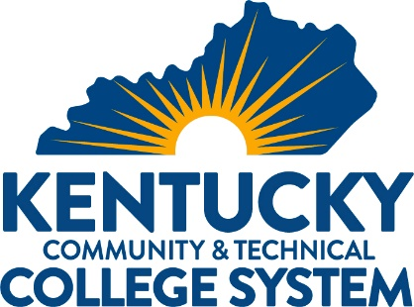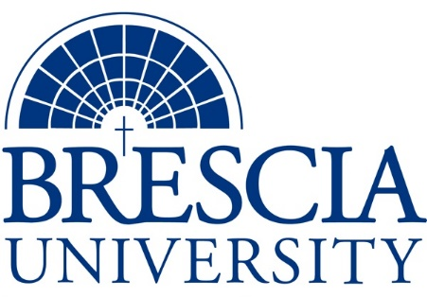

TRANSFER PATHWAY GUIDE

Associate of Applied Science to Bachelor in Integrated Studies
Diesel Technology, Construction Equipment Technician

Overview
Completion of the following curriculum will satisfy the requirements for Associates of Applied Science at the Kentucky Community and Technical College System and leads to a Bachelor’s Degree at Brescia University.

Admission Requirements
Official transcript from all schools attended. Combined grade point of average of a 2.0 or higher.

Degree Requirements
Students can apply to Brescia University at: https://www.brescia.edu/apply/ For any questions or additional information on tuition, deadlines, or start dates, please email BUconnections@brescia.edu

General Transfer Requirements
Brescia University can accept up to 77 hours of transfer credit from KCTCS from their associate of applied science for courses where a student made a grade of C or above.

KCTCS AAS TO BU’s Bachelor Degree CHECKLIST

Kentucky Community and Technical College System

Category 1: KCTCS General Education Core Requirements (15 hours)
KCTCS Course | Course or Category | Credits | {Institution}  Course | Completed
 | Quantitative Reasoning | 3
 | Natural Sciences | 3
 | Social/ Behavioral Sciences | 3
 | Heritage/ Humanities* | 3
ENG 101 | Written Communication | 3
 | Subtotal General Education Core Courses | 15
*World History is required at Brescia University. If not taken at KCTCS, will need to be taken at Brescia.

Category 2: KCTCS Technical and Support Component (50-52 hours)
KCTCS Course | Course or Category | Credits | {Institution}  Course | Completed
 | Computer/Digital Literacy | 3
BEX 100 AND BEX 101 OR ADX 120 AND ADX 121 OR ELT 110 | Basic Electricity for Non-Majors AND Basic Electricity Lab for Non-Majors OR Basic Automotive Electricity AND Basic Automotive Electricity Lab OR Circuits I | 5
ADX 170 | Climate Control | 3
ADX 171 | Climate Control Lab | 1
DIT 103 | Preventive Maintenance Lab | 2
DIT 110 AND DIT 111 OR ADX 150 AND ADX 151 | Introduction to Diesel Engines AND Introduction to Diesel Engines Lab OR Engine Repair AND Engine Repair Lab | 5
DIT 112 | Diesel Engine Repair | 3
DIT 113 | Diesel Engine Repair Lab | 2
DIT 140 AND DIT 141 OR FPX 100 AND FPX 101 | Hydraulics AND Hydraulics Lab OR Fluid Power AND Fluid Power Lab | 5
DIT 150 | Power Trains | 3
DIT 151 | Power Trains Lab | 2
DIT 190 AND DIT 191 OR ADX 260 AND ADX 261 | Electrical Systems for Diesel Equipment AND Electrical Systems for Diesel Equipment Lab OR Electrical Systems AND Electrical Systems Lab | 5
DIT 121 OR IMT 100 AND IMT 101 OR WLD 120 AND WLD 121 | Introduction to Maintenance Welding Lab OR Welding for Maintenance AND Welding for Maintenance Lab OR Shielded Metal Arc Welding (SMAW) AND Shielded Metal Arc Welding (SMAW) Lab | 3-5
DIT 123 | Undercarriage Lab | 3
DIT 152 | Powertrain for Construction Equipment | 3
DIT 153 | Powertrain for Construction Equipment Lab | 2
 | Subtotal AAS Technical Courses | 50- 52

BRESCIA UNIVERSITY

Major Requirements for Integrated Studies, Emphasis in Business
Brescia University Course | Course Name | Credits | {Institution} Course | Taken at KCTCS
Eng 102 | Writing II | 3
Eng 201 | Intro to Fiction | 3
Sph 110 | Public Speaking | 3
CS 105 | Office Applications | 3
Spn 101 | GER Foreign Language | 3
Drm 325 | Oral Interpretation (GER UD Fine Arts) | 3
Eng 341 or 342 | GER UD Literature | 3
Phl 346 | Business Ethics (GER UD Philosophy) | 3
Psy 105 | Intro to Psychology (GER Social Beh Sci) | 3
Th 318 | Faith & Justice (GER UD Theology) | 3
BAd 301 | Business Law | 3
BAd 405 | Management Information Systems | 3
BAd 410 | Public Regulation of Business | 3
Mgt 306 | Management Concepts | 3
Mkt 307 | Marketing Concepts | 3
BAd 418 | Quantitative Methods for Business | 3
Mgt 315 | Personnel/Human Resource Management | 3
IS 499 | Sr. Capstone (Final Paper Required) | 3
SW 310 | Social Issues and Diversity (UD Elective) | 3
Mgt 308 | Organizational Behavior (Or another UD Elective) | 3
Eco 201 | Principles of Economics I (or another Free Elective) | 3
Eco 202 | Principles of Economics II (or another Free Elective, if needed) | 3
 | Subtotal BRESCIA Credit Hours | 61-63
 | Total Baccalaureate Degree Credit Hours | 128
Updated: {8-26-2020}

