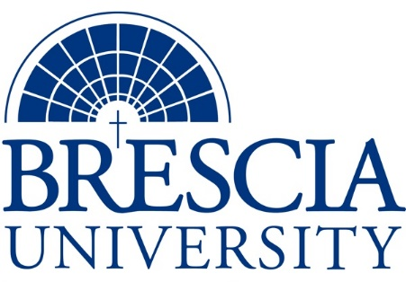

TRANSFER PATHWAY GUIDE

Associate of Applied Science to Bachelor in Integrated Studies
Business Administration, Hospitality Management

Overview
Completion of the following curriculum will satisfy the requirements for Associates of Applied Science at the Kentucky Community and Technical College System and leads to a Bachelor’s Degree at Brescia University.

Admission Requirements
Official transcript from all schools attended. Combined grade point of average of a 2.0 or higher.

Degree Requirements
Students can apply to Brescia University at: https://www.brescia.edu/apply/ For any questions or additional information on tuition, deadlines, or start dates, please email BUconnections@brescia.edu

General Transfer Requirements
Brescia University can accept up to 77 hours of transfer credit from KCTCS from their associate of applied science for courses where a student made a grade of C or above.

KCTCS AAS TO BU’s Bachelor Degree CHECKLIST

Kentucky Community and Technical College System

Category 1: KCTCS General Education Core Requirements (18 hours)
KCTCS Course | Course or Category | Credits | {Institution}  Course | Completed
MAT 110, MAT 150, or higher | Quantitative Reasoning | 3
 | Natural Sciences | 3
ECO 201 or ECO 202 | Social/ Behavioral Sciences | 3
 | Heritage/ Humanities* | 3
ENG 101 | Written Communication | 3
COM 181 | Basic Public Speaking | 3
 | Subtotal General Education Core Courses | 18
*World History is required at Brescia University. If not taken at KCTCS, will need to be taken at Brescia.

Category 2: KCTCS Technical and Support Component (44 hours)
KCTCS Course | Course or Category | Credits | {Institution}  Course | Completed
CIT 105 OR OST 105 | Introduction to Computers OR Introduction to Information Systems | 3
ENG 102 | Writing II | 3
BAS 160 | Introduction to Business | 3
BAS 260 | Professional Development and Protocol | 2
BAS 270 | Business Employability Seminar | 1
BAS 267 | Introduction to Business Law | 3
BAS 282 OR MKT 282 | Principles of Marketing | 3
BAS 283 OR MGT 283 | Principles of Management | 3
ACC 201 | Financial Accounting | 3
ACC 202 | Managerial Accounting | 3
HOS 100 | Introduction to Hospitality | 3
CUL 100 | Introduction to Culinary Arts | 2
HOS 282 | Tourism Marketing | 3
 | Technical Course Electives | 9
 | Subtotal AAS Technical Courses | 44

BRESCIA UNIVERSITY

Major Requirements for Integrated Studies, Emphasis in Accounting
Brescia University Course | Course Name | Credits | {Institution} Course | Taken at KCTCS
Eng 201 | Intro to Fiction | 3
Spn 101 | GER Foreign Language | 3
Drm 325 | Oral Interpretation (GER UD Fine Arts) | 3
Eng 341 or 342 | GER UD Literature | 3
Phl 346 | Business Ethics (GER UD Philosophy) | 3
Psy 105 | Intro to Psychology (GER Social Beh Sci) | 3
Th 318 | Faith & Justice (GER UD Theology) | 3
Acc 301 | Intermediate Accounting I | 3
Acc 302 | Intermediate Accounting II | 3
Acc 304 | Advanced Managerial Accounting | 3
Acc 401 | Advanced Accounting | 3
Acc 402 | Governmental and Nonprofit Accounting | 3
Acc 404 | Federal Individual Taxation | 3
Acc 410 | Auditing | 3
IS 499 | Sr. Capstone (Final Paper Required) | 3
SW 310 | Social Issues and Diversity (UD Elective) | 3
Mgt 308 | Organizational Behavior (Or another UD Elective) | 3
Eco 201 | Principles of Economics I (or another Free Elective) | 3
Eco 202 | Principles of Economics II (or another Free Elective) | 3
 | Free Electives, if needed | 9
 | Subtotal BRESCIA Credit Hours | 66
 | Total Baccalaureate Degree Credit Hours | 128
Updated: {8-26-2020}

