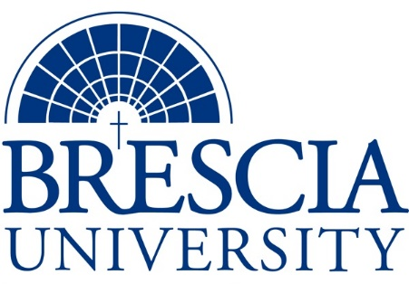

TRANSFER PATHWAY GUIDE

Associate of Applied Science to Bachelor in Integrated Studies
Administrative Office Technology, Administrative Management Track

Overview
Completion of the following curriculum will satisfy the requirements for Associates of Applied Science at the Kentucky Community and Technical College System and leads to a Bachelor’s Degree at Brescia University.

Admission Requirements
Official transcript from all schools attended. Combined grade point of average of a 2.0 or higher.

Degree Requirements
Students can apply to Brescia University at: https://www.brescia.edu/apply/ For any questions or additional information on tuition, deadlines, or start dates, please email BUconnections@brescia.edu

General Transfer Requirements
Brescia University can accept up to 77 hours of transfer credit from KCTCS from their associate of applied science for courses where a student made a grade of C or above.

KCTCS AAS TO BU’s Bachelor Degree CHECKLIST

Kentucky Community and Technical College System

Category 1: KCTCS General Education Core Requirements (18-19 hours)
KCTCS Course | Course or Category | Credits | {Institution}  Course | Completed
MAT 110 or higher | Quantitative Reasoning | 3
 | Natural Sciences | 3-4
 | Social/ Behavioral Sciences | 3
 | Heritage/ Humanities* | 3
ENG 101 | Written Communication | 3
COM 181 | Oral Communications | 3
 | Subtotal General Education Core Courses | 18-19
*World History is required at Brescia University. If not taken at KCTCS, will need to be taken at Brescia.

Category 2: KCTCS Technical and Support Component (42 hours)
KCTCS Course | Course or Category | Credits | {Institution}  Course | Completed
OST 105 | Introduction to Information Systems | 3
OST 110 | Document Formatting and Word Processing | 3
OST 160 | Records and Database Management | 3
OST 210 | Advanced Word Processing Application | 3
OST 215 | Office Procedures | 3
OST 235 | Business Communications Technology | 3
OST 240 | Software Integration | 3
OST 275 | Office Management | 3
ACT 101 or higher | Fundamentals of Accounting I OR Higher Level Accounting Course | 3
OST 220 | Administrative Office Simulation | 3
OST 225 | Introduction to Desktop Publishing | 3
OST 295 OR COE 199 | Administrative Office Technology Internship OR Cooperative Education | 3
ENG 102 | Writing II | 3
 | Elective course approved by Program Coordinator | 3
 | Subtotal AAS Technical Courses | 42

BRESCIA UNIVERSITY

Major Requirements for Integrated Studies, Emphasis in Business
Brescia University Course | Course Name | Credits | {Institution} Course | Taken at KCTCS
Eng 201 | Intro to Fiction | 3
Spn 101 or Frn 101 | GER Foreign Language | 3
Drm 325 | Oral Interpretation (GER UD Fine Arts) | 3
Eng 341 or 342 | GER UD Literature | 3
Phl 346 | Business Ethics (GER UD Philosophy) | 3
Psy 105 | Intro to Psychology (GER Social Beh Sci) | 3
Th 318 | Faith & Justice (GER UD Theology) | 3
BAd 301 | Business Law | 3
BAd 405 | Management Information Systems | 3
BAd 410 | Public Regulation of Business | 3
Mgt 306 | Management Concepts | 3
Mkt 307 | Marketing Concepts | 3
BAd 418 | Quantitative Methods for Business | 3
Mgt 315 | Personnel/Human Resource Management | 3
IS 499 | Sr. Capstone (Final Paper Required) | 3
SW 310 | Social Issues and Diversity (UD Elective) | 3
Mgt 308 | Organizational Behavior (Or another UD Elective) | 3
Eco 201 | Principles of Economics I (or another Free Elective) | 3
Eco 202 | Principles of Economics II (or another Free Elective) | 3
 | Free Elective | 3
 | Free Elective | 3
 | Free Elective | 3
 | Free Elective | 3
 | Subtotal BRESCIA Credit Hours | 68
 | Total Baccalaureate Degree Credit Hours | 128
Updated: {8-26-2020}

